Thermal osmosis
Background. It has recently been found that hydrophobic membranes with pores of nanometer size will not transport water in the liquid state, but rather in the vapor state, when surrounded by water solutions at different temperatures. This opens up for a very interesting way to clean contaminated water by means of industrial waste heat. The figure illustrates an invention that puts this into practice. Water is transported against a pressure gradient by means of a temperature gradient. This is what we understand as thermal osmosis.
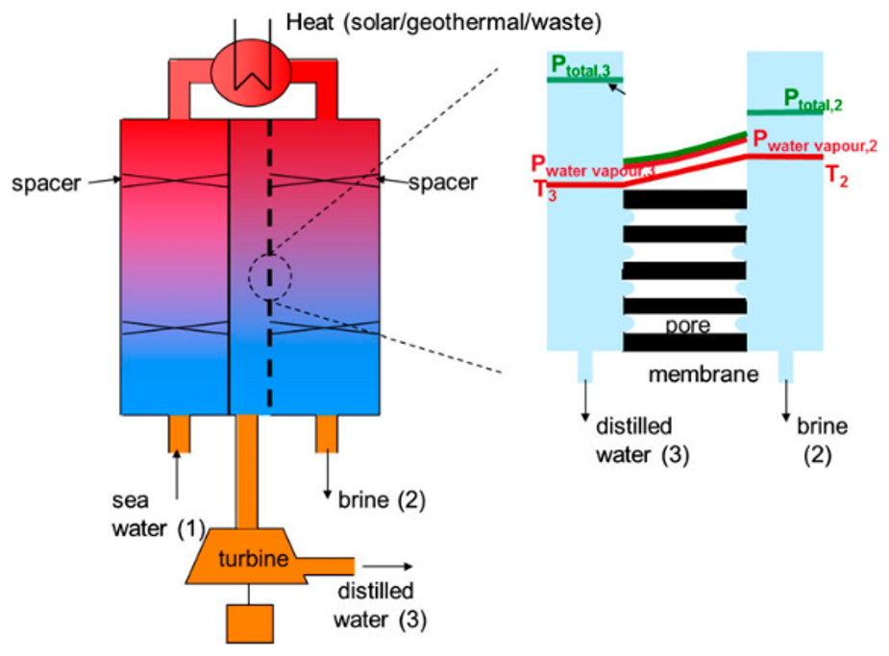

Problem formulation. The mechanism for water transport in the membrane that is used in the invention is little understood. The aim of the project is to help us understand how exactly (with what speed) water is passing the membrane. By understanding the transport better, we hope to improve conditions for it. The work will consist of setting up a NEMD model for water transport across a narrow pore, and study of the wall and pore shape affects the transport under relevant temperatures and pressures.
Other aspects. This study can benefit from similar studies, because one student will probably be able to simulate transport properties for one membrane only. Accompanying studies of different membranes may give more insight. The project will benefit from experimental activities in our group (one Master student, Kristiansen, and partner in Spain).
Supervisor team. The project will be carried out guided by weekly meetings in a supervisor team consisting of Signe Kjelstrup, and PoreLab colleagues.
References:
- Keulen et al. J. Membr, Sci. 524 (2017) 151
- Lee et al. Nature Nanotechnology 9 (2014) 317
Soret effects in porous media.
Background. The heat evolution in Li batteries need to be controlled to understand why the battery sometimes overheat and catch fire in the surroundings. During the course TKJ4200, the Soret effect was investigated in an electrolyte mixture of components, LiPF₆, ethylene carbonate and di-methyl carbonate. The investigation was done with LAMMPS software. The study showed that it was likely that all components were moving in a thermal field. The results were not conclusive, however, and we would like to verify them
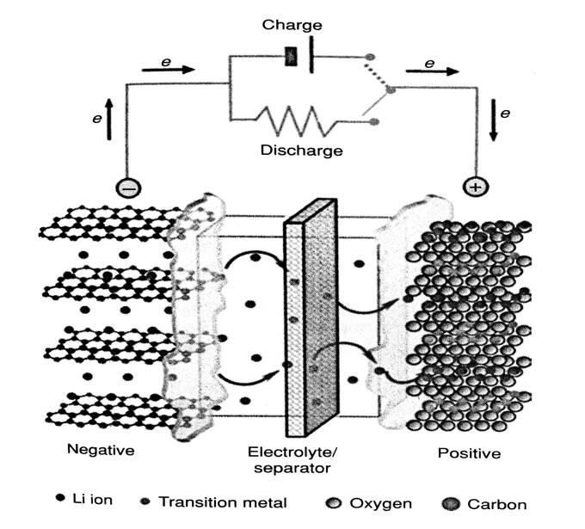
Fig.1 The electrolyte and electrodes in a Li battery
Problem formulation. In order to reach valid conclusions, it is an advantage to build the system gradually and introduce new variables in a stepwise manner. It thus is interesting to study the single components, before a mixture, and a mixture before a ternary mixture. We will study all 4 cases in equilibrium in order to characterize the equilibrium state. When that is known, we apply the temperature gradient, and find the Soret coefficient for each of the systems.
Other aspects. The student may benefit from similar studies going on in the group, from experimental as well as computational activities on ionic systems (one Master student, Gunnarshaug, and students working on Seebeck coefficient problems). The project can start within the frame of the course TKJ4510 Fordypningsemner which runs in the fall semester. The aim of this project will be to establish the technique, and define the equations to be used for the master project that runs in the spring semester.
Supervisor team. The project will be guided by weekly meetings by a supervisor team consisting of Signe Kjelstrup and colleagues.
Reference: Scrosati et al. Li-Batteries, 2013
Molecular dynamics simulations of the Seebeck effect in porous media
The Seebeck effect can be used to convert thermal energy to electrical energy. This project is an extension of master student Didrik Roest’s work (2016) on molecular dynamics simulations of salts between two walls. In the present project, the salt is in a bulk phase with local heat source and sink terms that generate a thermal gradient. The aim is to find the effect on the charge separation in the salt and the consequent relation between the voltage and the thermal gradient.
Other aspects. A Master project in our group (Gunnarshaug) is measuring Seebeck coefficients for Li-Battery components. This project will support her studies and vice versa. One student will probably be able to simulate transport properties for one ionic mixture only. Supervisor team. The project will be carried out guided by weekly meetings in a supervisor team consisting of Signe Kjelstrup and colleagues. International contact is Fernando Bresme, Imperial College

