Master project: Steady state two phase flow experiments in 3D

Simultaneous flow of two fluid phases in a porous medium will after a transient state often lead to a steady state regime where all measurable quantities have a well defined statistical distribution with well defined averages. Experiments in quasi 2D systems have been performed in the past in our group for horizontal models. The goal of this experiments is to perform steady state experiments in 3D with density matched fluids to prevent buoyancy effects. This project is of central importance for comparison with theoretical model building in PoreLab. In two dimensional systems it has been found an unusual scaling relation between the flow rate and the pressure, and we wants to investigate the relation between the pressure and the flow rate for a three dimensional system. This project is also great technological interest for fluid flow in oil and water reservoirs an addition to CO₂ sequestration in porous media.

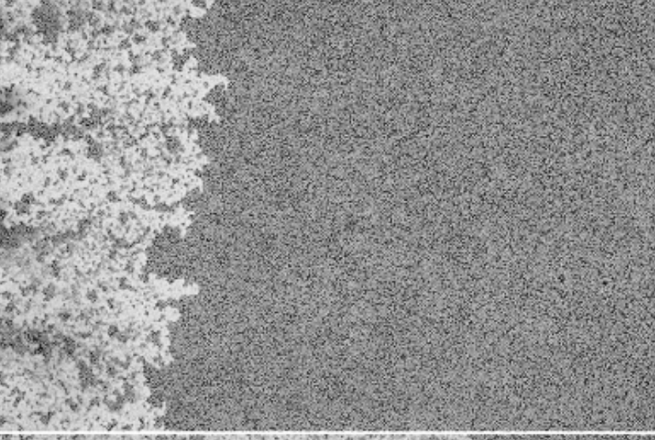

Figure: Steady state flow in a quasi 2D model system Simultaneous injection of a glycerol/water (black) solution and rapeseed oil (white).

