Master project: Modeling a cyclic granular plug formation process

A large variety of porous material can be found in nature. The properties of a fluid flow across porous media has been a long standing topics in Physics. Here we are proposing to describe the progress of a gas/liquid interface across a deformable porous media made of glass beads confined in a millifluidic glass tube. Such systems are known to produce rich patterns. The instability generating the structuring relies on the competition between the driving capillarity, and the dissipating viscous or frictional interaction. In a cylindrical confinement the granular material, initially sedimented, is organized into a series of granular plugs, spaced by empty gaps. The interpretation of the cyclic process is not completely understood and requires some thermodynamical modeling. Pattern formation in deformable porous media has recently been a very active research topic with potentially innovating bridges towards other fields in Physics.
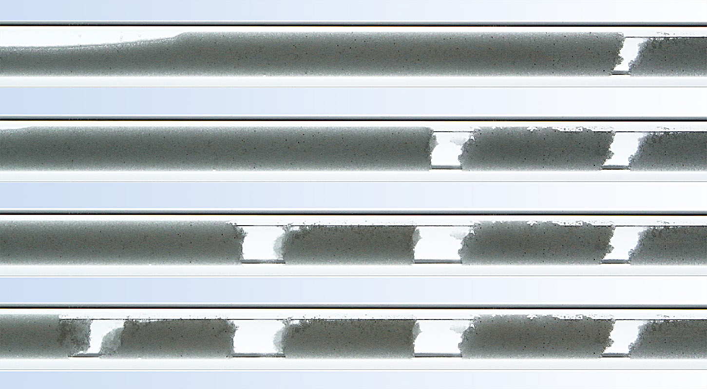

Figure 1: Formation of a series of granular plugs as a gas/liquid interface is progressing from right to left. The snapshots are taken at regular time intervals from top to bottom. The deformable granular material used here is made of 50 micrometers glass beads, confined in a 2 mm diameter glass tube. The liquid is removed from the left tube’s outlet by a syringe pump, which drives the gas/liquid interface.

