Master project: Granular plug dynamics in confined geometry

Granular material confined in cylindrical geometries exhibits a rich physics when a fluid interface is driven across. Capillary effects, viscous and frictional dissipation compete together to determine the dynamics of a frictional fluid. This project suggests to identify and characterize the parameters controlling the formation and displacement of a granular plug. The experimental results should rely on an effective modeling of the involved stresses, taking into account the different states of the granular plug (static or dynamic, compacted, fluidized, etc.). In this complex system made of a large number of grains, the dynamics at the grain level is coupled to the dynamics of the whole plug. The dynamics of granular materials in confined geometries has a strong potential interest in medical or chemical setups featuring multiphase processes. It should also bring an important milestone in the modeling of geophysical processes where the confinement is a key parameter, and granular material a widespread ingredient.
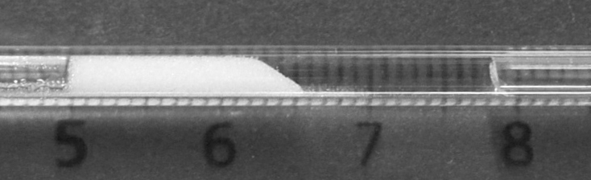
Figure 1: Granular single plug in a 2 mm diameter cylindrical glass tube. The initially sedimented granular material made of 50 micrometers glass beads form a granular plug as the meniscus is driven against it. The driving dynamics is controlled by the imposed pressure difference across both sides of the plug.

