Master project: Fast deformation and fracturing during fluid injection into a porous reservoir model

When a fluid is injected into a porous medium at a sufficient overpressure or flow rate, it will deform the medium and open up flow channels/fractures. The formation of these channels increases the permeability of the medium, which can be an advantage. Processes like this often occur in industry, for example to enhance oil & gas recovery, CO₂ storage, water well- and thermal energy production. As a side effect, such fluid injections also lead to changes in the stress state of the reservoir rock surrounding the channels, which may de-stabilize the region. Industrial fluid injections and deposits have led to deformation and pressure changes in the earth’s crust resulting in unwanted damage, even earthquakes far away from tectonic plate boundaries.
The main task in this project will be to perform systematic experiments, where air or water is injected into a granular medium confined inside a quasi-2D flow cell. Several parameters can be varied to explore the impact on the channels formed and surrounding deformation, including the injection method, boundary conditions, fluids, and composition of the medium. Increased knowledge of the physics in this topic helps to gain more control and reduce risk during processes like hydraulic fracturing.

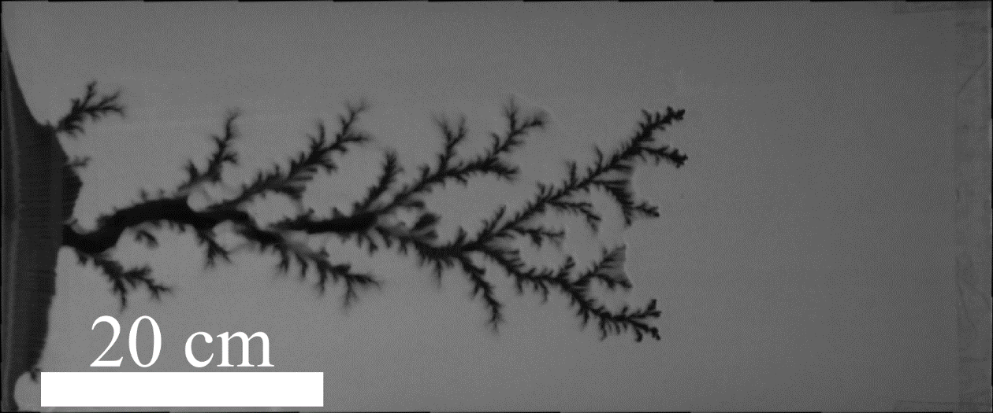
Figure 1. A top-down image of the invasion channels (black) formed in a granular medium between two glass plates (gray) when air is injected from the left side at a constant pressure of 200 kPa. The long sides of the cell are completely sealed, while the right side has a filter which stops beads but allows air to escape. In this experiment, pressurized air forces its way through the medium to reach the atmosphere, leading to the formation of these branched channels.

