Master project: Steady state two phase flow in a gravitational field

Simultaneous flow of two fluid phases in a porous medium will after a transient state often lead to a steady state regime where all measurable quantities have a well defined statistical distribution with well defined averages. Experiments in quasi 2D systems have been performed in the past in our group for horizontal models. The goal of this project is to investigate the influence of buoyancy effects by changing the gravitational constant in the direction of the flow. This will be done by systematic tilting the models. The goal is to measure the fluid saturation and the distribution of trapped fluid clusters, the pressure drop across the model, and the dynamics linked to snap-off coalescence and migration of clusters. This project is of great interest in comparison with theoretical model building in PoreLab. It is also of great technological interest for fluid flow in oil and water reservoirs an addition to CO₂ sequestration in porous media.
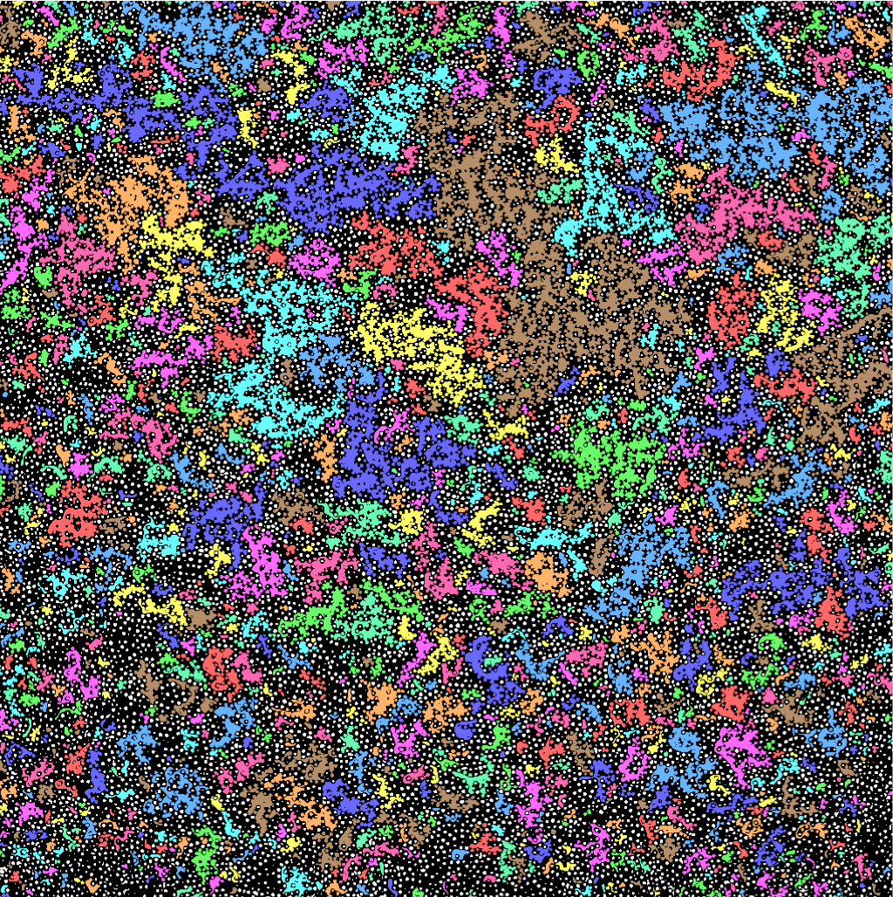

Figure: Steady state two phase flow experiments in a horizontal quasi 2D porous media. Air and a glycerin water solution is injected simultaneously into the porous medium. The colors indicates different cluster sizes of trapped air.

