Masters project: influence of the flow speed on the pore invasion dynamics
The investigation of porous media flows is a topic of pivotal importance for several aspects of human activity. The extraction of water from natural reservoirs and the recovery of oil from subsea rocks are two examples where the knowledge of porous media physics brings immediate economical and societal impact. Since the visualization of flows in porous media can be very challenging, numerical simulations have been used to study the morphology and dynamics of flow structures both in fast and slow injection processes. With the development of modern high-resolution and high-speed imaging techniques, we are now in position to address experimentally questions that previously could only be accessed via numerical simulations. In this project we will investigate, both experimentally and analytically, how the invasion dynamics of a pore is affected by speed of the flow.

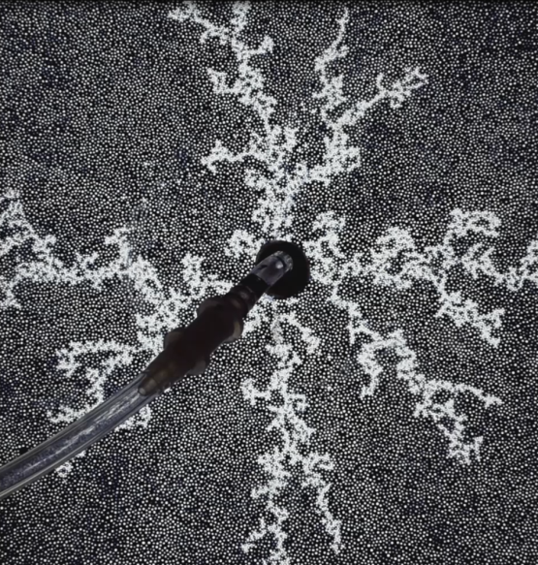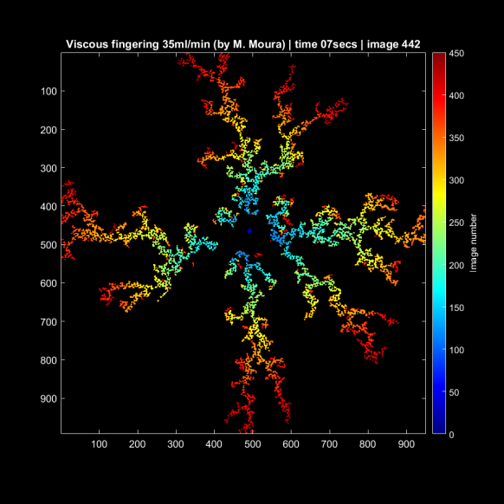
Figure : Viscous fingering pattern (left) observed when air is injected fast in a porous medium previously filled with a viscous liquid (blue). The image analysis (left) shows the time (image number) of injection of each pore.

